**MyTasks**

Version 1.1

**USER MANUAL**

**Uses**

This app is a good tool for keeping track of how long assignments are taking you versus how long you think they will take you. It’s best used as a tool to help you better yourself and your time management skills. In this manual, we will explore how to do basic and more advanced functions of this app.

**Basic Functions**

**Setup**

When you first begin this app, you will be presented with dialog boxes which require you to input how much time you think an easy, medium, and difficult task will take you.

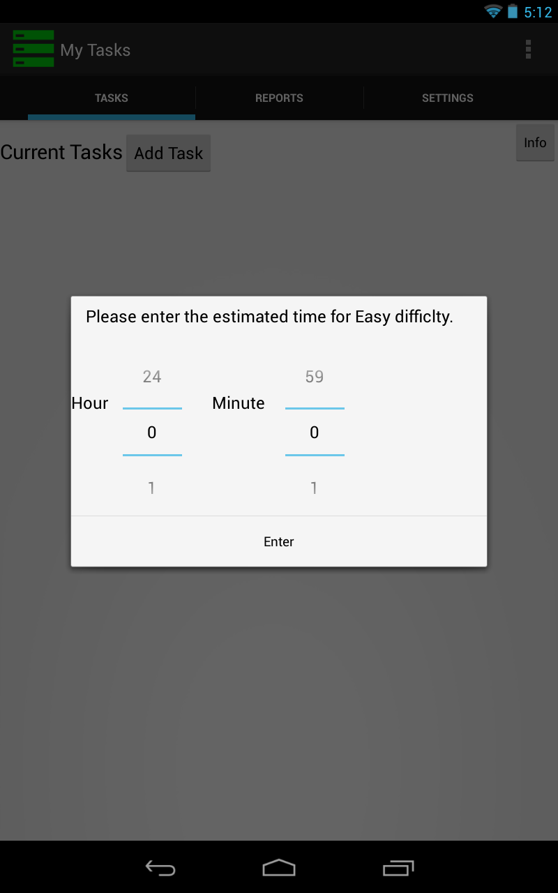

**Add a Task**

In order to add a new task, you need to tap the “Add Task” button on the “Tasks” tab. Then another view will pop up in which you type in the name of the task. Tap the appropriate buttons to select the due date, due time, and the difficulty of the task. Then tap the “Done” button to signify that you are done with adding the task. If you do not fill in all the information, you will not be able to successfully enter the task. If you do not wish to enter a new task, you can tap the default android back button in order to cancel.

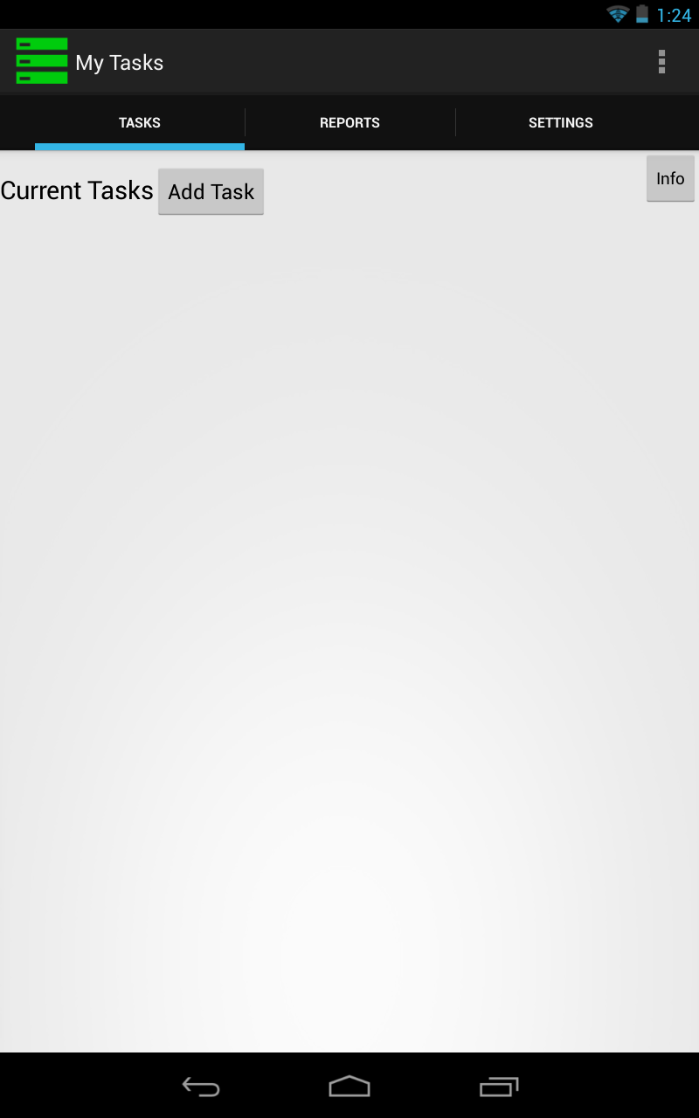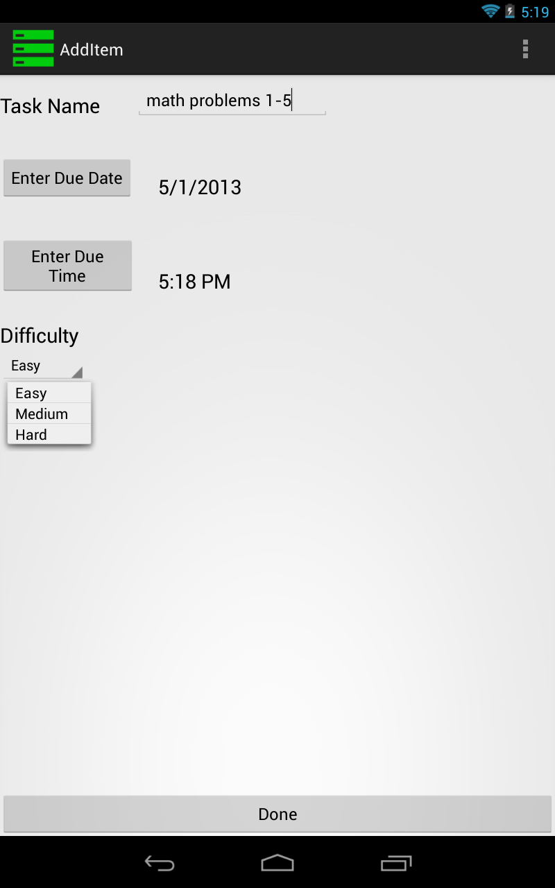

**Begin a Task**

In order to show that you have begun working on a task, tap the task you wish to begin. A dialog box will pop up. Choose “Begin Task” from there. You will receive a message that the task has begun.

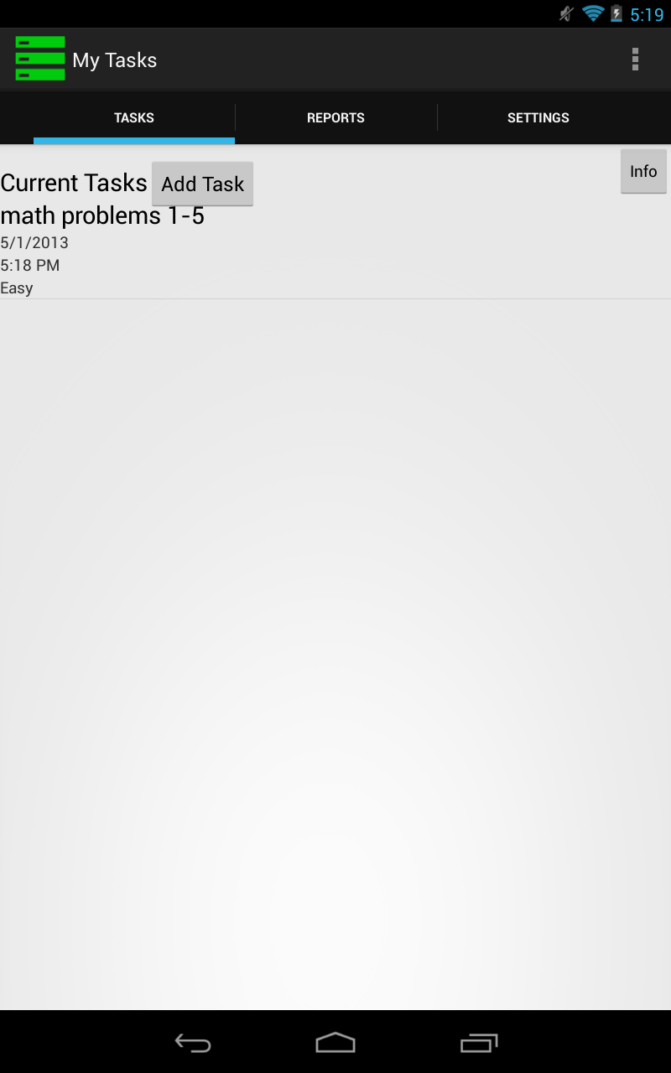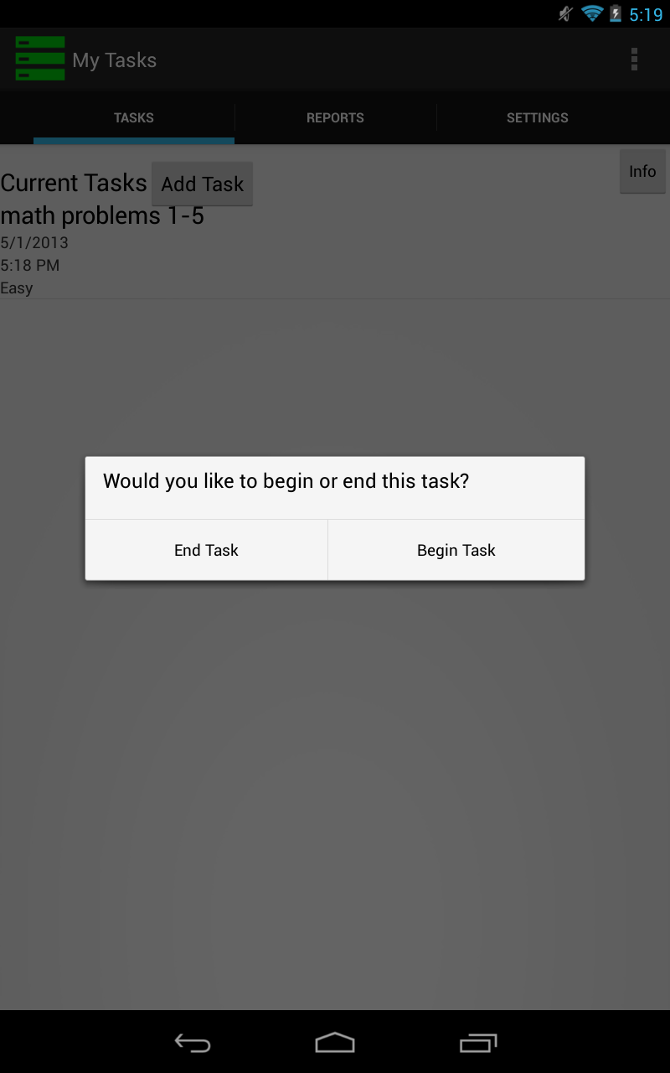

**Complete a Task**

In order to show that you have finished working on a task, tap the task you wish to finish. A dialog box will pop up. Choose “End Task” from there. You will receive a message that the task has been completed



**Advanced Features**

**Reports**

To see current reports about your tasks, tap on the middle tab, “Reports.” Here you will see the raw number data for reports detailing how many tasks have been completed vs not, how many tasks were completed on time vs not, and the number of tasks that were completed under, over, and near the estimated time per difficulty. Next to each set of data is a “Show Chart” button. Once you tap on this button, you will be shown a pie chart that corresponds to a breakdown of the left side numbers as a portion of the pie of the total number of tasks.

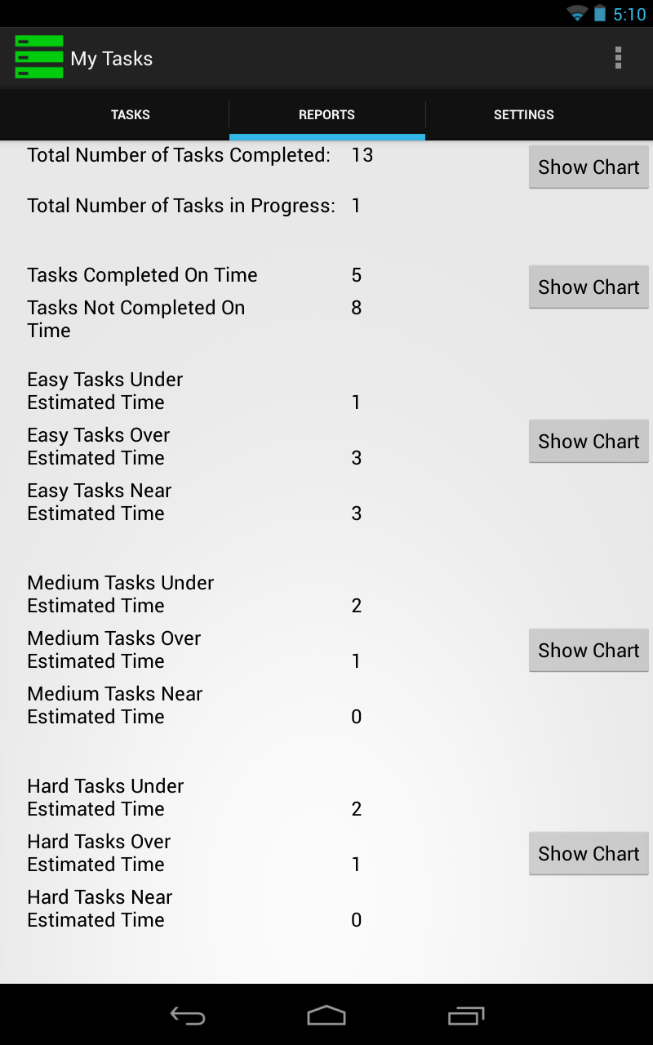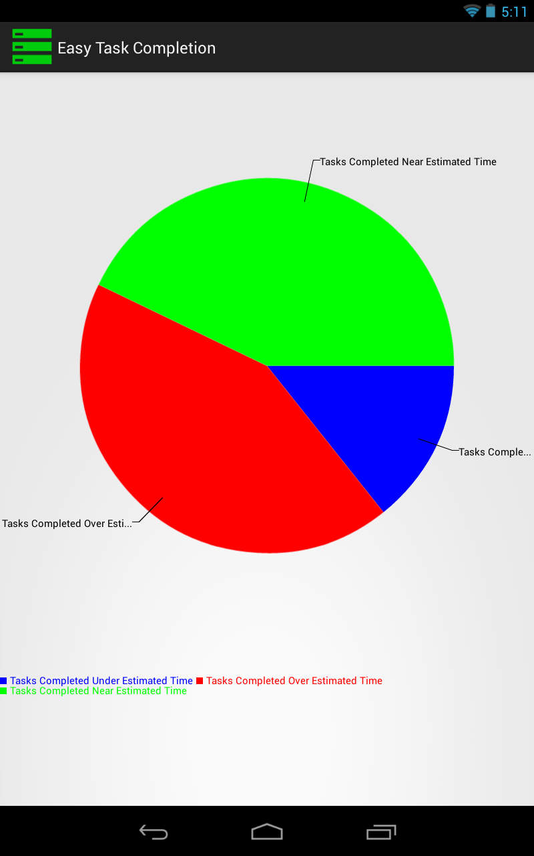

**Set Difficulty Level Time Estimate**

In the beginning, before you ever add a task to your to-do list, you were shown a group of 3 times back-to-back. This sets the base line for how long you think an easy, medium, and hard task will take. Later, you may want to change that number. In order to do that, go to the settings tab on the far right and select the difficulty for which you want to change the estimated time. There, you will have a dialog pop up and select the time from there.

